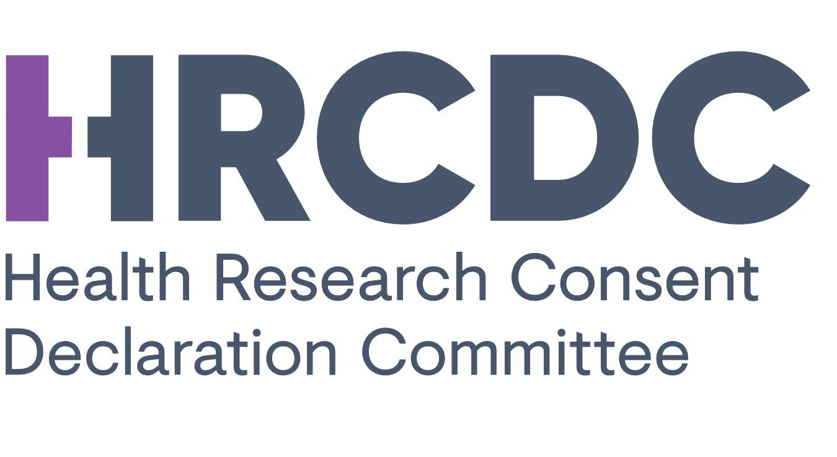

CONSENT DECLARATION ANNUAL REVIEW FORM

It is a standard condition of a consent declaration, that the Data Controller must submit an Annual Review to the HRCDC as required by Health Research Regulations. Please complete the Annual Review application form and return it to Secretariat@hrcdc.ie

PLEASE NOTE
- Pre-submission advice can be sought from the Secretariat; Secretariat@hrcdc.ie
- The HRCDC is a body formed under statutory instrument (S.I. No. 314 of 2018 and as amended by S.I. No. 188 of 2019 and S.I. No.18 of 2021)
- The information provided within this form is subject to the Freedom of Information Act, 2014
- Please do not provide surplus documentation unless specifically requested
- Electronic signatures are acceptable
- Please submit a non-scanned PDF (converted from Word)
- Please do not alter the content of the Annual Review Form
- Please consult with the Data Protection Officer of the Data Controller
- Please carefully read the explanatory notes in each section

PART A: APPLICANT DETAILS

Application reference ID
Include the reference ID to any amendments approved by the HRCDC, as appropriate

Ref ID:

Title of Research

Data Controller(s)

Name all joint data controller organisations, if more than one

Applicant/Principal Investigator:
Name:
Email:
Telephone:

PART B: PROGRESS OF THE RESEARCH STUDY

Provide a brief overview of the progress of the research study to date or since the last annual review update (if applicable) (Max 200 words)
Please include an overview of the general deliverables and impacts of the study to date. Please use non-technical language and non-confidential information. If the outputs of study have been published, please cite any references as appropriate. If the research study has ended a statement to this effect will suffice

Please provide the approximate number of Irish patients covered by the consent declaration

Comment on any material changes to research study

-Please comment on any changes that have been made to the research study, such as data controllers, purpose, the scope of data processing, additional personal data being processed, research ethics approval amendments etc.

-If material changes have been made, explain why it was not necessary to notify the HRCDC of these changes by way of an applying for an amendment to the consent declaration.

☐ No changes have been made
Details of changes made:

Comment on any breaches that have occurred that affect the integrity of the Declaration and the protection of data subjects

As a standard condition of a consent declaration, Applicants are to report on breaches that may have occurred (e.g., data ransom, unauthorized data access etc.)

☐ No breaches have occurred
Details of breach, who was informed and actions taken:

PART C: CONSENT DECLARATION

Is the consent declaration still valid, or required?
If the consent declaration has expired since the date made by the HRCDC, or is no longer required, please outline how the personal data that was processed under the consent declaration, has been destroyed or rendered fully anonymised, or if explicit consent has subsequently been obtained from the study participants. Generally, outline how the exit strategy has been implemented.

☐ Valid/required [Please complete section 4]
☐ Expired
☐ No longer required.

Details:

Consent declaration requirement: Provide an update on the Exit strategy if different from the information provided in the original application. If no change since the previous information, please tick relevant box below to confirm. Example of change in exit strategy includes whether the data will be deleted or fully anonymised earlier than planned.

☐ No change to exit strategy.

Details of change:

- Please indicate if the research study and analysis of data has been completed and personal data is being stored only at this time. (i.e. the only processing activity is storage)
☐ Yes
☐ No
If yes, then questions 7&8 are not applicable.

i) Outline how the specific Conditions attached to the consent declaration and amendments if applicable, have been met
Please provide substantiating documentation or evidence where appropriate e.g.
- Where conditions are a specific reporting requirement of the HRCDC, please report on the status and implementation of the condition.
- Where conditions relate to transparency measures, provide privacy/data protection notices, publicity campaigns, website links, other relevant documentation.
- Where conditions relate to public and patient involvement (PPI), please comment on PPI feedback, engagement and how the study has implemented PPI advice or feedback.
- Where conditions relate to the consent and assent protocol, please comment on how the advice of the HRCDC has been taken into consideration.
- Where conditions relate to security measures, please comment on implementation of enhanced measures.

☐ Not Applicable
Condition 1:
Condition 2:
Repeat if necessary

ii) Outline why specific Conditions attached to the consent declaration and amendments if applicable, have not been met
Please provide substantiating documentation or evidence where appropriate. Where conditions have not been met, clearly outline the challenges experienced or mitigating actions taken, or what progress has been made to date.
☐ Not Applicable
Condition 1:
Condition 2:
Repeat if necessary

PART C: OTHER
- If changes have been made to the original Data Protection Impact Assessment
- summarise the changes made,
- provide feedback/advice of the Data Protection Officer.
Please outline any specific risks highlighted by the DPO, and advice provided to mitigate any risks.
Please attached a copy of the updated DPIA. Where the application is from joint data controllers, the advice of each data controller’s DPO must be attached.
☐ No Changes
Summary of Changes:
Feedback/Advice of DPO:
☐ Copy of Updated DPIA attached

SIGNATURE PAGE TO FOLLOW
PART E: SIGNATURES – THIS FORM SHOULD BE SIGNED BY THE PRINCIPAL INVESTIGATOR IN IRELAND. ALERNATIVELY IT MAY ALSO BE SIGNED BY THE DATA CONTROLLER OF THE STUDY.
PRINCIPAL INVESTIGATOR IN IRELAND #1
I hereby submit this Annual Review to the Health Research Consent Declaration Committee. To the best of my knowledge all the information provided herein is correct.
Applicant Name:
Organisation:
Title:
Signature: _________________________________________
Date:

PRINCIPAL INVESTIGATOR IN IRELAND #2
I hereby submit this Annual Review to the Health Research Consent Declaration Committee. To the best of my knowledge all the information provided herein is correct.
Applicant Name:
Organisation:
Title:
Signature: _________________________________________
Date:

