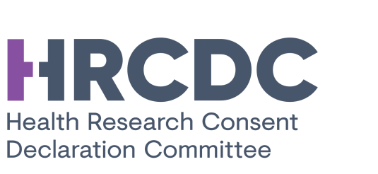

HRCDC Cookie Policy
Title: | Cookie Policy - Public
Document Type: | Notice
Reference/version no: | 1.0
Status: | Final
Last Updated: | 05.06.2019
Background: | Outward facing cookie policy notice - posted online

Table of Contents
- Who we are
- Website
- What are cookies and why do we use them?
- Blocking cookies

Who we are
Please review the HRCDC Privacy Notice for further details on the HRCDC.

Website
The HRCDC fully respects your privacy. We do not gather or harvest any personally identifiable information from visitors to our website. We do capture some routine web browsing information, such as;
- your web browser
- your operating system
- what pages you visit and for how long
We use this data to continually improve our site in accordance with user needs.
We have a wide range of audiences, with non-overlapping information needs, and we want to make sure that we consistently deliver the right information to each group and as quickly as possible.

What are cookies and why do we use them?
What is a cookie?
A cookie is a small file of letters and numbers containing information that is stored on your browser or the hard drive of your computer. A cookie can be used to identify a user’s computer or internet enabled device to the website, or to other third party websites.
Why do we use them?
Our website uses cookies to distinguish you from other users of our website. This helps us to provide you with a personalised experience when you browse our website and also allows us to improve our site. Cookies are also necessary for the website to function; they exist on our website but are outside our control and therefore cannot be switched off in our systems – they are generated by individual web browsers
What cookies do we use?
- Strictly necessary cookies:
These cookies are necessary for the website to function and cannot be switched off in our systems. They are always active. They are usually only set in response to actions made by you. The HRCDC do not use these cookies to collect or store any personally identifiable information about you;
- Google Fonts
- Google Maps
- Adobe Typekit
Google Fonts and Maps cookies may record where you are accessing the website from if you are signed-in to your Google. The HRCDC have not control over this and we do not have access to this information.
Other cookies have been added to the site via a security plugin. The cookies have been added for antispam purposes to monitor automatic ‘bots’ who aim to log-in to the website. Again these cookies do not contain any personal or sensitive information. WP Cerber does not use cookies to store any personal identifiers.
- Third party cookies:
Third parties (including, for example, advertising networks and providers of external services like web traffic analysis services) may also use cookies, over which we have no control. These cookies are likely to be analytical/performance cookies or targeting cookies.

Blocking cookies
You can block cookies by activating the setting on your browser that allows you to refuse the setting of all or some cookies. You can access the “Help” function in your browser to find out more. However, if you use your browser settings to block all cookies (including essential cookies) you may not be able to access all or parts of our site. All cookies will expire after 30 days.

