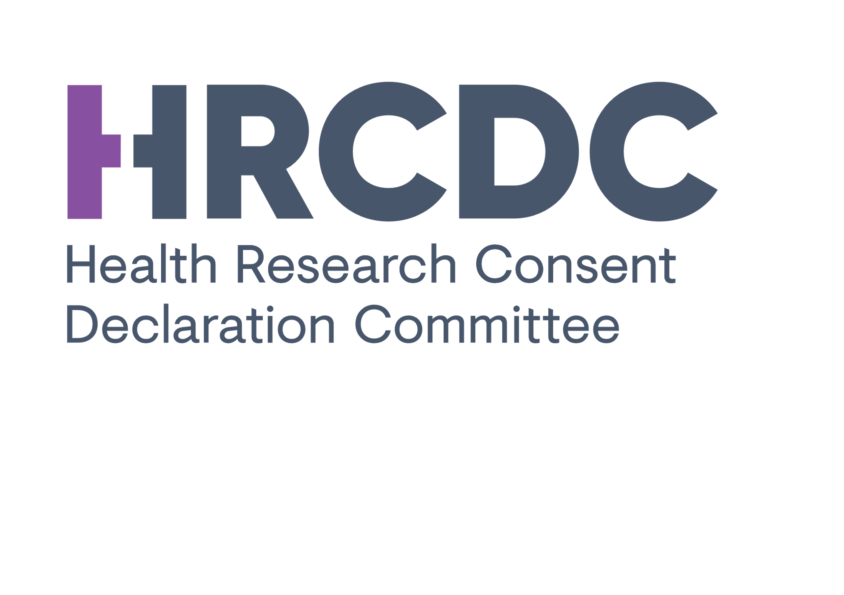
Minutes of the Induction Meeting of the
Health Research Consent Declaration Committee
-
27th March 2019
Grand Canal Hotel, Grand Canal Street, Dublin 2

Present
Name | Position
Brigid McManus | HRCDC Chairperson
Prof. Evelyn Mahon | HRCDC Deputy Chairperson
Ms. Alyson Bailey | HRCDC Member
Mr. Dan Rea | HRCDC Member
Dr Simon Furney | HRCDC Member
Dr Aideen Hartney | HRCDC Member
Dr Claire Collins | HRCDC Member
Dr Sheelah Connolly | HRCDC Member
Dr Zubair Kabir | HRCDC Member
Ms. Kathy Brickell | HRCDC Member
Mr. Kevin Clarke | HRCDC Member
Prof. Barry O’ Sullivan | HRCDC Member
Prof. Bert Gordjin | HRCDC Member
Dr. Emily Vereker | Secretariat
Mr. Jonny Barrett | Secretariat
Ms. Shirley Murphy | Secretariat

Absent Members
Name | Position
Dr. John Ferguson | HRCDC Member
Prof. Malcom Kell | HRCDC Member

Also in attendance for items 1-5
Name | Position (reason for attending)
Dr. Teresa Maguire | Speaker (Dept of Health)
Mr. Peter Lennon | Speaker (Dept of Health)
Mr. David Murphy | Speaker (Data Protection Commission)
Dr. Darrin Morrissey | Guest, Health Research Board
Dr. Mairead O’ Driscoll | Guest, Health Research Board

Meeting Agenda
- Introductions
- Chairperson and HRCDC Members
- Secretariat
- Department of Health
- Data Protection Commission
- Data Protection Commission - Speaker - David Murphy
- Health Research Regulations - Speaker - Peter Lennon
- Overview and Context for the HRCDC - Speaker - Teresa Maguire
- Q&A
- HRCDC Operations Overview -Speaker Emily Vereker & Brigid McManus
- Standard Operating Procedures
- Consent Declaration application forms - overview and context
- Conflict of Interest
- HRCDC Meeting times - dates
- GDPR Consent Forms
- Expenses
- Communication channels - emails, correspondence
- AOB

- Introductions
Brigid McManus (HRCDC Chairperson) opened the induction meeting. The HRCDC Members, secretariat and guest speakers participated in a quick introduction about themselves. Teresa Maguire thanked all the committee members for agreeing to join the HRCDC and noted the importance of the work that the committee will be doing.

- Data Protection Commission
Speaker: David Murphy, Assistant Commissioner.
Verbal presentation
David Murphy (DM) provided an overview of the Data Protection Commission with respect to health research. DM Highlighted major developments in the Data Protection legislation and noted that the Health Research Regulations are now a core part of the Commissioner’s framework alongside GDPR and the Data Protection Act.
DM stated that the Committee is about balancing public interest with the need for consent and that the Regulations are important from a legal point of view and for data subject confidence and trust.
The relationship between the Data Controller and Processor is now clear and opinions of the European Court of Justice have played an important role. Controllers need to oversee compliance with data protection obligations and require support to do so. It is very important that DPOs are involved in assessing and mitigating risk to the data subject which will be outlined in DPIAs - all high risk scenarios with no risk mitigation should be discussed with the DPC. DPOs are mandated to provide both an advisory and monitoring role through the GDPR. DPOs should be embedded in organisations and have acceptable supports to carry out their duties. DM highlighted the importance of explicit consent from data subjects and stated that DPOs should always be the first point of contact when Data Controllers are seeking support including on preparing applications to the HRCDC. Where the DPC need to be contacted this should be via the organisation’s DPO. The DPC is happy to provide any guidance in the background to DPOs such as assistance in completing a DPIA.
As part of its statutory function the DPC should be contacted where high level risks identified in a DPIA cannot be mitigated. The DPC can also examine data governance structures and provide guidance in this area – it can also provide guidance on transparency measures.

- Health Research Regulations
Speaker: Peter Lennon Dept. of Health
Peter Lennon (PL) provided an overview of the Regulations. The Regulations bring consistency, clarity and certainty to the data subject. PL spoke about consent in reference to Article 4 – sufficient information must be required, and the data subject needs to be able to read and digest this properly. Research that foregoes consent and confidentiality must have a very strong public interest case. Researchers need to be ethical and professional when handling patient treatment. Explicit consent needs to be informative and recorded. Blanket consent is not compatible or acceptable with data protection since 2011. In relation to Biobanking and Clinical trials - these fall under the Health Research Regulations. PL stated that Biosamples and personal data cannot be divorced from each other. Activities under consideration for review: Retrospective chart reviews, capacity to consent, deferred consent, administration data, clinical audit versus research and pre-screening. Any amendments proposed can only be accepted by the DPC if there are moves towards improved changes in governance structures, as such the DPC will need to know what is happening and changing in the area of health research. To sum up, consent needs to be informed and explicit and the public interest needs to significantly outweigh the need to acquire consent.
PL’s presentation slides are attached as follows;
- Overview and Context of the HRCDC
Speaker: Teresa Maguire, Dept. of Health
Verbal presentation
Teresa Maguire (TM) spoke of the work being undertaken within the Department of Health including improving health research activity and engagement within the Health Service. TM stressed the need to improve training, data sharing, research quality and collaborations, including with commercial entities and that the Department are consistently thriving for improvements. TM mentioned that throughout the system the patients and public need to feel good about transparency notices and delivery of care. This is important not just in hospitals but in all institutions and at every level including GP practices, public health, rehab centres, palliative care etc. TM commented that a research active system helps to recruit and retain staff and deliver better healthcare. Some issues arising are cross border collaborations and clinical research. With respect to applications for the HRCDC, it’s important to note, it is not just patient’s data that may be collected and used for health research. Data maybe collected from the homeless, prisons, asylum, clinical and population health which may be the subject matter of the applications going before the HRCDC. Another example that would fall within scope of the HRCDC is where data is transferred from a country where explicit consent is not required.
TM noted that public trust in our health care sector is not high and there is a need for an education campaign; data subjects are not always sure what they are signing up for and they want more information as people need to be more informed. Surveys indicated that the Irish public are generally satisfied with providing anonymous data but much less so to allow GPs to provide personal data for research without their knowledge - other concerns arise with commercial interest or involvement. The Committee is one part of the process to try and obtain safer and more impactful health research in Ireland. TM also spoke about the Confidentiality Group in England and Wales and similar institutions/ guidelines in N. Ireland, Australia and Canada that the HRCDC can draw upon. TM concluded that the DoH and DPC will continue to work and support researchers to better understand the legal framework they should be working in.
TM Speaking notes attached as follows:

- Questions and Answers
There was a Q&A from the HRCDC Members put forward to TM, PL and DM:
Q1. Where does the remit of the Health Research Regulations end, is there an element of policing on what should come to the HRCDC? – It isn’t clear that everything that should come to the Committee will come to the Committee.
A1. Context is essential for all cases – it will be the context of the study that determines whether it is classed as health research or not. Applications that do not come to the HRCDC are not something the HRCDC should try and control or influence as it is the responsibility of the data controller to ensure they are compliant with the Regulations. The Committee may find receive an application that may or may not be defined as health research. DPOs have a critical role to play in this, for example by engaging with staff in their organisations to ensure they are collecting and using data compliant to the legislation. Institutions/funders need to be aware of the legislation requirements. It was noted that there is no HRCDC equivalent for non-health research.
***
Q2. Are the Regulations being used by other sectors to avoid seeking consent?
A2. The DPC will want to see what legal basis has been established by the data controller and also what conditions under which data should be processed (referencing Art6 and Art9 of GDPR) eg the commercial sector such as ‘FitBits’/health or lifestyle sector. It was noted that the Health Research Regulations do not address the lawfulness for processing data and other obligations under GDPR and so cannot be used to get around GDPR.
***
Q3. Anonymisation?
A3. The data controller must consider the reasonable likelihood of a data subject being re-identified. It is for each data controller to satisfy themselves that data is anonymised (that re-identification is not possible and check the risks of their approach via a DPIA). The DPC confirmed that Data protection law does not apply to anonymous data but a number of factors need to be taken into account to ensure data is anonymous
***
Q4. Can legal advice be sought for the HRCDC?
A4. The HRCDC can access specific independent legal advice, facilitated by the HRB. Any general queries regarding the Regulations could be fielded by the Dept. of Health.
***
Q5. Who is the Applicant, who is the Data Controller? Who should act as a DPO?
A5. DPOs must be published on institution’s website and notified to DPC. DPC has encouraged DPO networks to be set up. European Data Protection Board (EDPB) has an opinion piece on DPOs. https://ec.europa.eu/newsroom/article29/item-detail.cfm?item_id=612048
It was stated that the institution that holds the data is normally the controller - data controller is defined as the living person or institution that decides on the methods and/or purpose of processing data.
***
Q6. If applicants are not using consent as legal basis what can applicants use as a legal basis?
A6. Data protection law requires a legal basis under Article 6 for all personal data processing as well conditions under Article 9 for processing special category data. However the Health Regulations require explicit consent as a safeguard when conducting health research. The DPC commented that the Art 6 legal basis would be interesting should the project be a joint one where one of the controllers is a public body i.e. a public body cannot use legitimate interest as a legal basis. Furthermore transparency is a new principle brought in by GDPR and suitable and specific safeguards are also required.
***
Comment: The transition period deadline of April 30th was raised as an issue with respect to ability of the committee to review applications in time.
Response: It was acknowledged that this deadline was an issue and discussions were underway regarding the deadline.

***

Health Research Board
Darrin Morrissey, CEO, Health Research Board joined the meeting and welcomed the HRCDC members and spoke about the HRB perspective. It was highlighted that a lot of investment has been made in Irish health research over a number of years and that the convening of the HRCDC is a very positive development for health research. The HRB is happy to support the work through its organizational support for the Secretariat. This led to a more general discussion. It was noted that there are messages/concerns that are coming from the research community on the requirements and these have been taken on board by D/Health.
The issues of consent and the declaration process are extremely important, non-trivial considerations. The difference between the work of the HRDC and Ethics committees was noted. The potential development of a national REC was noted as an important future link. The difference between data protection consideration and ethics consideration was also discussed, in particular the 'data lifecycle' - data will live on after the research has concluded
Members were reminded that if applicants should or could obtain consent from the data subjects it is not the role of HRCDC to grant a declaration to say that they do have to obtain consent – declarations are only to be considered where it is no feasible to obtain consent.

- HRCDC Operations Overview
Speakers: Emily Vereker and Brigid McManus
Slide presentation
Emily Vereker (Secretariat, Programme Manager) and Brigid McManus spoke about the SOP draft, consent declaration application forms and Conflict of Interest policy. All members were provided with a draft SOP document and asked to review and revert with comments. A difference between the proposed HRCDC SOP and the processes used by the Confidentiality Advisory Group (CAG) in the UK was noted; the use of a lead reviewer in CAG which may be considered at a later date for HRCDC but is not suggested at this initial stage.
Future meeting dates were discussed and a Doodle Poll will be sent out to all members. GDPR Consent forms and expenses will be discussed further at a later date. EV spoke about communication channels: press, social media, FOI and emails. All media queries should go to the Chair and/or Secretariat for consideration.
The independent role of the HRCDC was referenced. It was stressed that the Secretariat has no decision making role.
It was queried how to ensure corrections of information, documents received from the applicant and the need for due-diligence. The committee discussed in general whether a check is needed to confirm that the DPO noted in the application is the DPO – or more generally to check if they have authority to sign the application form. Question was ‘is this the role of the secretariat?’ It was discussed that the Secretariat should not have carry out this level of due diligence, but always consider whether the information provided appears appropriate. It was commented that Section F of the application form guidance notes confirmed the sign off process and is clear on the authorities that should have reviewed and/or signed on the application.

Declarations of Interest were discussed; BMcM provided examples eg. participation of other committees or boards, financial interests.

The committee discussed times and duration of meetings - it was suggested that at 10.30 start would work to allow all members to get to the meeting location on time.

- AOB
The Secretariat was asked about the volume of applications received. The secretariat confirmed 2 and stated that many queries had been received which suggested many applications were in draft. It was queried whether applicants or observers would be allowed to attend Committee meetings. Attendance of applicants or observers is outlined in the SOPs- but this would only occur in exceptional circumstances where perhaps the HRCDC felt the application was very complex. EV stated that applicants should be in able to make a strong case through the application form, which would ensure all applicants had an equal footing.

It was queried how the applications would come to the committee. EV discussed having dedicated IT reading room for application review - for security purposes. iPads were discussed as the device to be used to allow secure access and reading of applications. Until this is in place, applications will be sent via email to the committee password protected.
***
Meeting closed

