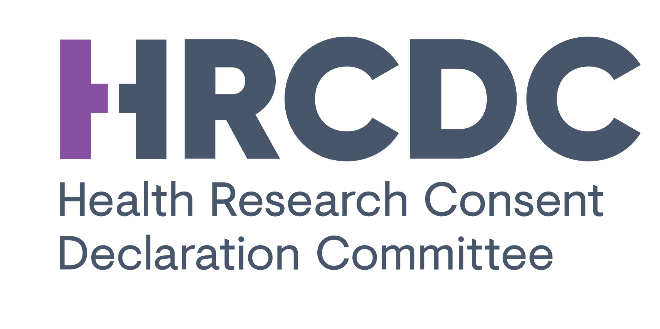
Update: Possible amendments to Health Research Regulations - Matters under consideration by the Department of Health
Ongoing Health Research (Regulation 6 of the Health Research Regulations)
The Department of Health have announced that engagement with the Data Protection Commission and the Department of Justice and Equality on the Health Research Regulations has led to agreement that the time frame for obtaining explicit consent for the processing of personal data for a health research project that was ongoing on 8 August 2018 is to be extended to 7 August 2019. It is also being provided that where an application for a consent declaration in relation to such research is made to the Consent Declaration Committee before 7 July 2019 the requirement for consent will not apply until such time as the Committee makes a decision on the application. It is important to note that all other safeguards required by the GDPR, the Data Protection Act 2018 and the Health Research Regulations must be in place.
The Data Protection Commission has advised the Department of Health that it is not open to any further extensions on this matter.
Other matters
The Department continues to consult with the Data Protection Commission and the Department of Justice and Equality on the other matters referenced in the Department’s Public Notice of 8 April.
In that regard, the Data Protection Commission has agreed that the requirement for explicit consent for retrospective chart review studies carried out in a data controller’s organisation by
(a) a health practitioner employed by the data controller (including students studying, in the data controller’s organisation, to be health practitioners who are under the supervision of the health practitioner) or
(b) an employee of the data controller (other than a health practitioner in (a)) who, in the course of his or her duties for the data controller, would ordinarily have access to health record information held by the data controller and who, in the circumstances, owes a duty of confidentiality (that includes specified penalties for any breach of that duty) to the data subject that is equivalent to that which would exist if that person were a health practitioner.
that are low risk with high transparency arrangements in place will continue to be deferred pending the conclusion of discussions between the Department of Health and the Commission on this matter and the introduction of a more formalised arrangement through an amendment to the Health Research Regulations.
The existing facilitation on not requiring explicit consent for retrospective chart reviews previously agreed with the Commission was due to lapse on 30 April and the Department is grateful to the Commission for agreeing an extension. Again, it is important to note that all other safeguards required by the GDPR, the Data Protection Act 2018 and the Health Research Regulations must be in place, including approval by a research ethics committee. The Commission are also particularly concerned that highly visible transparency measures are adopted and that risk assessments are carried out and recorded.
The Department of Health will continue to update as appropriate.

***

