CDCAF1

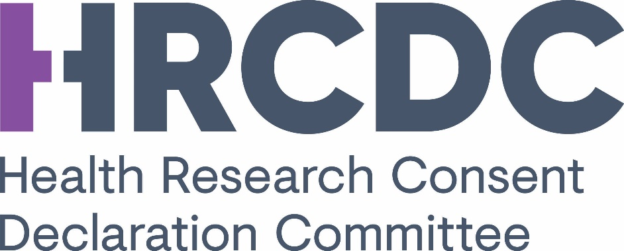

APPLICATION FORM
TO PROCESS OR FURTHER PROCESS PERSONAL DATA FOR THE PURPOSES OF HEALTH RESEARCH COMMENCING ON OR AFTER 8 AUGUST 2018

PART A: APPLICANT DETAILS

1. Name and address details (including website, if any) of data controller:

2. Lead contact person to receive correspondence in relation to this application:

3. Principal business of data controller:

4. If there are joint data controllers, please specify the name, address and principal business of joint data controllers and set out the division of responsibilities between them:

5. Name of addresses of data processors, if any –please attach a copy of the contract or draft contract that will be used:

6. Research site/s involved in processing activity:

7. Name of and contact details for Principal Investigator. If the Principal Investigator is regarded as the data controller, this should be made clear and information provided to support that view.

8. Co-Investigator name and contact details:

9. Collaborator name and contact details (and role in project):

10. (a) Is it proposed to process any personal data outside of the State?
Yes: No:

(b) If Yes, please specify the countries that this will take place in.

(c) If any of those countries are outside of the European Economic Area what is the legal basis for the transfer of the personal data?

11. Please specify any person, organisation or group from whom funding or other material support has been sought or is intended to be sought and indicate where such funding or support has been provided or committed at the time of this application.

12. Please specify any sponsor for the research activity (where appropriate)

13. Please specify any person (other than a joint data controller or data processor) with whom it is intended to share any of the personal data obtained or further processed (including where it has been pseudonymised or anonymised), the purpose of such sharing and the country that the person is located in.

14. Please list (below) all Research Ethics Committees involved in approval and attach copy of outcome letter from each of those RECs.

PART B: NATURE OF HEALTH RESEARCH AND PERSONAL DATA INVOLVED
1. Provide a lay summary of what the research is about and why the application is being made (Max 500 words)

2. Describe the nature and objective of the health research project for which the application is being made.

3. Indicate the start date and expected duration (months)

4. Specify the study endpoints/deliverables

5. Provide an overview of the proposed design and methodology (3 pages max to be attached).

6. Describe the personal data which will be obtained and used.

7. Explain why the health research requires that personal data be obtained and processed rather than anonymised data.

8. Describe how you will ensure, in relation to the research, that personal data already held and to be obtained will not be processed in such a way that damage or distress is, or is likely to be, caused to the data subject.

9. Describe how you will ensure that the collection and use of the personal data will go no further than is necessary for the attainment of the research objective (data minimisation principle).

10. Describe the data processing activities (data lifecycle and research lifecycle), focusing on access, storage, analysis, sharing, transfers, archiving and destruction

11. Confirm that there will be no disclosure of the personal data unless that disclosure is required by law or the data subject has given his or her explicit consent to the disclosure.

12. Identify the data sources from which the personal data will be obtained and any engagement, general or specific, with those sources on the likelihood that they will provide the personal data should a consent declaration be made .

13. If the research involves data linkage between different sources of information, you must describe what is involved and its purpose.

14. Describe your exit strategy with timelines to address the issues that led to this application, such that the research described will no longer require support under the consent declaration process. If you will continue to require the support of a declaration over a number of years, you must set out the reasons why that is the case.

15. Identify the particular part(s) of the research for which the consent declaration is sought.

16. Following on from 15, you must set out fully-
(i) why you claim it is not practicable to seek consent from the data subjects.

(ii) in what way was consent formally considered at the design or any stage of the research.

(iii) what consultations have you undertaken on the feasibility of obtaining consent: for example, focus groups?

(iv) the extent to which you have involved patient and user organisations/representatives in the development of the research.

(v) any other evidence you can provide in support of your application that obtaining consent is nor practicable.

PART C: LEGAL BASIS FOR THE PROCESSING OF PERSONAL DATA
1. Identify the legal basis under Article 6 and the relevant condition under Article 9 for the proposed processing of the personal data.

PART D: THE PUBLIC INTEREST CASE
1. Describe fully why you believe that the public interest in carrying out the health research significantly outweighs the public interest in requiring the explicit consent of the data subject and provide any supporting evidence for your case.

PART E: INFORMATION REQUIREMENTS, DATA SECURITY ARRANGEMENTS AND TRAINING
1. Specify the transparency arrangements you have/will put in place to ensure that personal data are processed in a transparent manner.

2. Identify the controls in place to-
(i) limit access to the personal data undergoing processing in order to prevent unauthorised consultation, alteration, disclosure or erasure of personal data;

(ii) log persons who access personal data;

(iii) technical, organisational and physical measures to protect the security of the personal data concerned;

(iv) arrangements to anonymise, archive or destroy personal data once the health research has been completed;

(v) any other technical and organisational measures designed to ensure that processing is carried out in accordance with the Data Protection Regulation, together with processes for testing and evaluating the effectiveness of such measures.

3. (a) Set out below a summary (max 750 words) of the findings of the Data Protection Impact Assessment that has been carried out and ensure that you have attached a copy of the DPIA.

(b) Indicate the steps you have taken to address any risks identified in the DPIA with particular reference to the possibility of data linkages and details of any consultations undertaken with data subjects.

(c) Please attach the advice of the Data Protection Officer on the research and any action taken in relation to that advice. Where the application is from joint data controllers, the advice of each data controller’s DPO must be attached.

4. Provide information on the training in data protection law and practice that has been provided to those individuals involved in carrying out the health research.

PART F: SIGNATURES - DATA CONTROLLER(S)
DATA CONTROLLER

I certify that I have been duly authorised by the data controller to forward this application by the data controller to the Health Research Consent Declaration Committee
APPLICATION TITLE:
PRINCIPAL INVESTIGATOR NAME:
Name:

Organisation:

Original signature: _________________________________________

Date:

DATA CONTROLLER (where there are joint data controllers)

I certify that I have been duly authorised by the data controller to forward this application by the data controller to the Health Research Consent Declaration Committee
APPLICATION TITLE:
PRINCIPAL INVESTIGATOR NAME:
Name:

Organisation:

Original signature: _________________________________________

Date:

If there are more than two joint data controllers, the above box should be copied as necessary.

